Unit Circle:

Key Points:
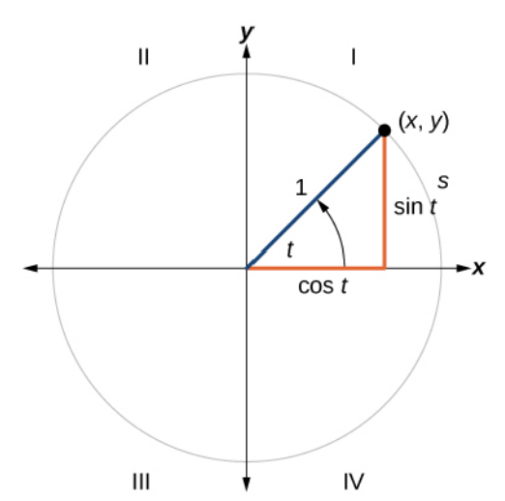

- A unit circle has a center at $(0,0)$ and radius 1. In a unit circle, the length of the intercepted arc $s$ is equal to the radian measure of the central angle $t$.
- Let $\left(x,y\right)$ be the endpoint of the unit circle of an arc length $s$. The $\left(x,y\right)$coordinates of this point can be described as functions of the angle $t$.
- Using the unit circle,
$\sin{t=\frac{Opposite}{Hypotenuse}=\frac{y}{1}=y}$, $\cos{t=\frac{Adjacent}{Hypotenuse}=\frac{x}{1}=x}$

When the sine or cosine is known, we can use the Pythagorean Identity

$$\sin^{2}{t}+\cos^{2}{t=1}$$
to find the other.

- $\tan{t=\frac{y}{x}}$ , $x≠0$, $\cot{t=\frac{x}{y}}$ , $y≠0$, $\csc{t=\frac{1}{y}}$ , $y≠0$ , $\sec{t=\frac{1}{x}}$ , $x≠0.$

- Reference angle $t'$ is an acute angle formed by the terminal side of an angle $t$ and the horizontal axis
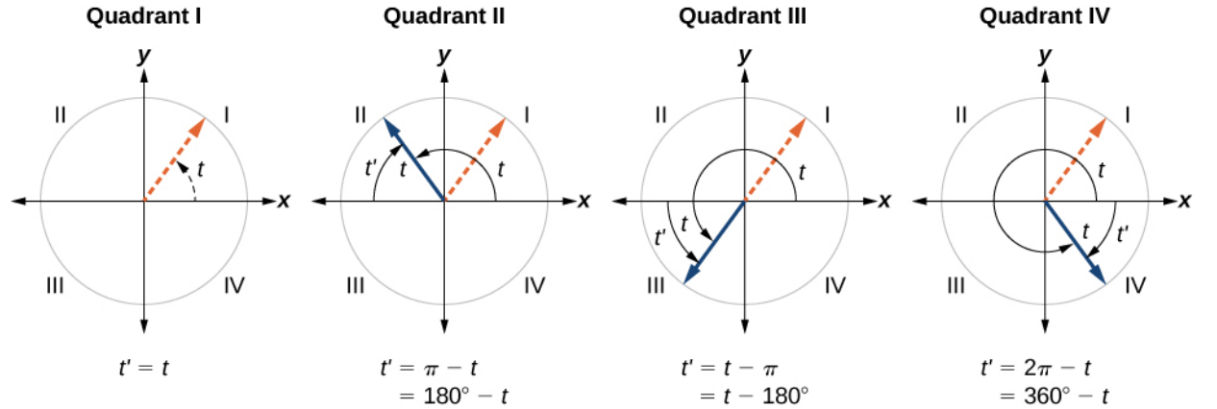
- Reference angles can be used to find the sine and cosine of the angle $t$ when $t$ is not an acute angle anymore.

- Reference angles can also be used to find the coordinates of a point on a circle.

- Special angles and coordinates of corresponding points on the unit circle

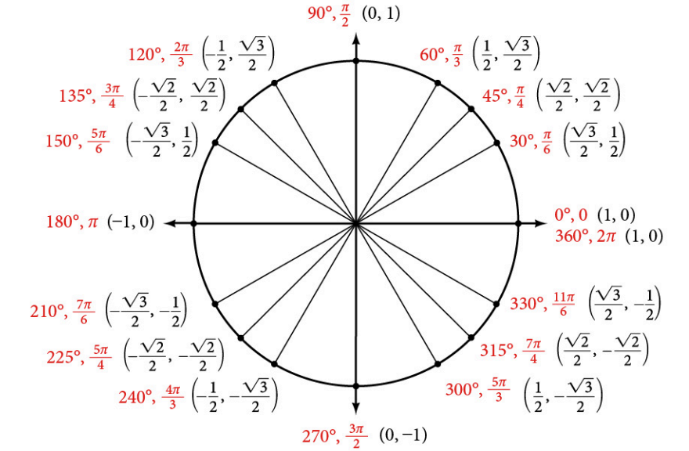

- The trigonometric functions are each listed in the quadrants in which they are positive.
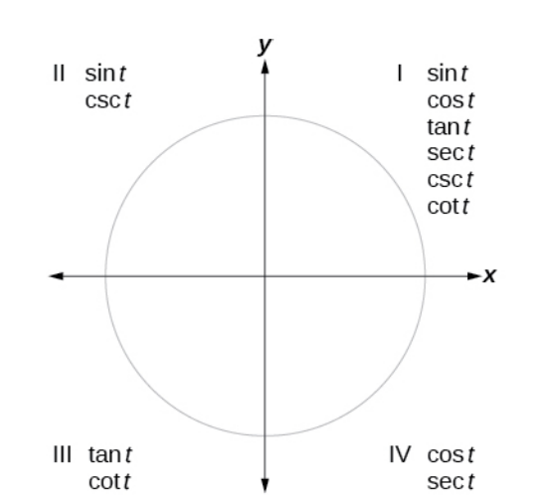

Unit Circle Videos:
- Finding Function Values for Sine and Cosine from the Unit Circle: Example 1
- Calculating Sines and Cosines along an Axis: Example 2
- Finding a Sine from Cosine or Cosine from Sine of an angle, given its quadrant location: Example 3
- Finding a Reference Angle: Example 4
- Using Reference Angles to Find Sine and Cosine: Examples 5-7
- Finding Trigonometric Functions from a point on the Unit Circle:: Example 8
- Finding the Trigonometric Function of an Angle: Example 9
- Using Reference Angles to Find Trigonometric Functions: Example 10

Practice Exercises:

For the following exercises, use the given sign of the sine and cosine functions to find the quadrant in which the terminal point determined by $t$ lies.
- $\sin\left(t\right)<0$ and $\cos\left(t\right)<0$

- $\sin\left(t\right)>0$ and $\cos\left(t\right)>0$

- $\sin\left(t\right)>0$ and $\cos\left(t\right)<0$

For the following exercises, find the exact value of each trigonometric function.
- $\sin\left(\frac{π}{3}\right)$

- $\cos\left(\frac{π}{4}\right)$

- $\cos\left(\frac{π}{3}\right)$

- $\sin\left(π\right)$

- $\cos\left(\frac{π}{6}\right)$

- $\cos\left(π\right)$

For the following exercises, state the reference angle for the given angle.
- ${240}^{°}$

- ${135}^{°}$

- ${100}^{°}$

- $\frac{2π}{3}$

- $-\frac{π}{8}$

- $-\frac{11π}{3}$

Answers:

- Quadrant III

- Quadrant I

- Quadrant II

- $\frac{\sqrt{3}}{2}$

- $\frac{\sqrt{2}}{2}$

- $\frac{1}{2}$

- 0

- $\frac{\sqrt{3}}{2}$

- $-1$

- ${60}^{°}$

- ${45}^{°}$

- ${70}^{°}$

- $\frac{π}{3}$

- $\frac{π}{8}$

- $\frac{π}{3}$

